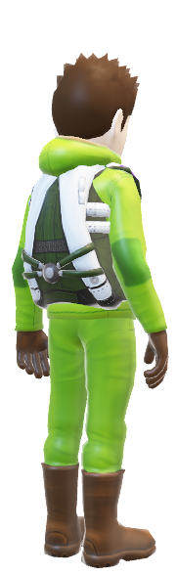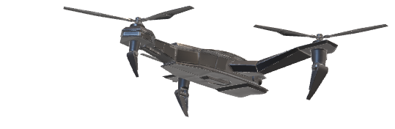**HOW IT WORKS (GENERAL OVERVIEW)**

UAV

Anchor

***Concept***

In order to accurately follow the remote anchor carried by (person), the UAV system will carry out a series of algorithms with the use of GPS and bluetooth to follow as precisely as possible.